Key Indicator - 6.2 Strategy Development and Deployment (10)
6.2.3 Implementation of e-governance in areas of operation (4)
- Administration
- Finance and Accounts
- Student Admission and Support
- Examination
Options: 1. All of the above

Areas of e governance | Year of implementation | Name of the Vendor with contact details | Link to relevant website/ document
Administration | 2013 | A & S Software Consultancy Private Limited, India (+91 70427 31360, director@assoftwaregroup.com) | http://online.imibh.edu.in/leave/
Screen Shot:

Areas of e governance | Year of implementation | Name of the Vendor with contact details | Link to relevant website/ document
Finance and Accounts | Visual Pay (2013) | M-Tech Software (Mr. Bhupender -9811982215) | http://visualurl.com
Finance and Accounts | Tally ERP 9 (2011) | Anu International (011-41638150, 011 -29211391) | http://www.anuinternational.co.in
Finance and Accounts | Web E-TDS (2020) | Webtel (Mr. Arijit Kundu - 8777791552) | www.webtel.in
Screen Shot:

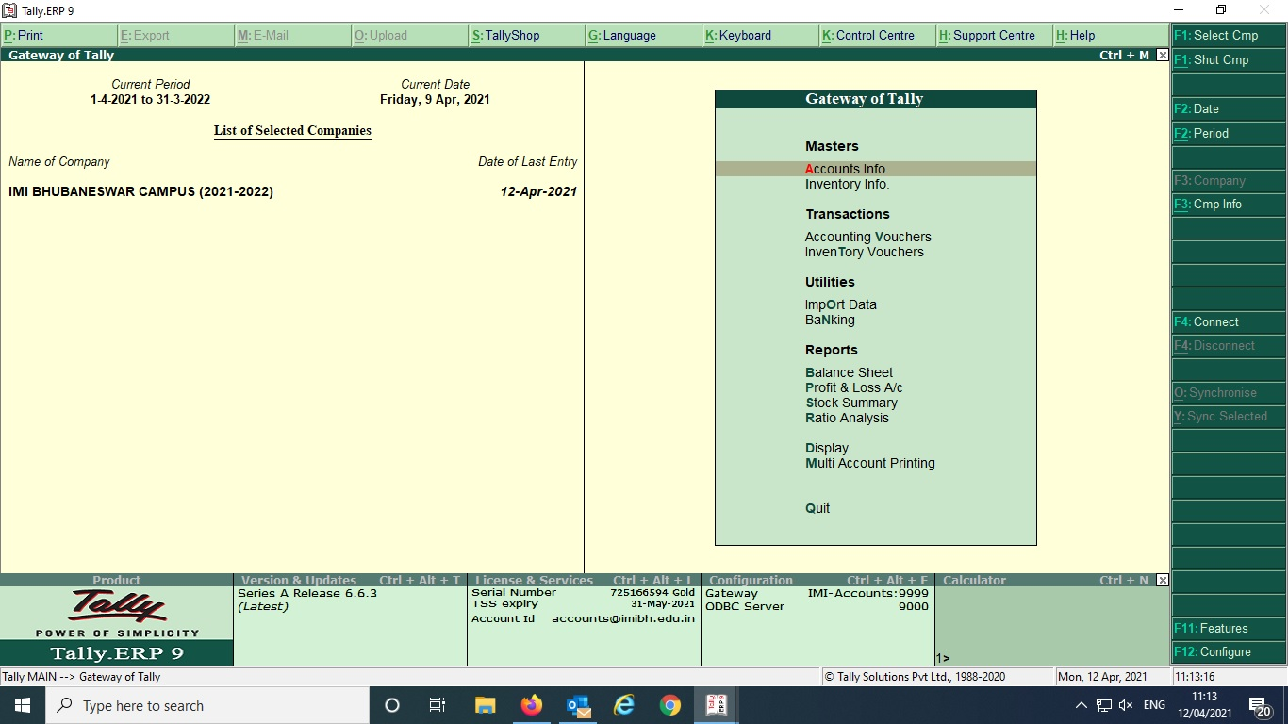

Areas of e governance | Year of implementation | Name of the Vendor with contact details | Link to relevant website/ document
Student Admission and Support | 2018 | Nopaperforms Solutions Private Limited  First Floor, Plot No. 242 and 243,  AIHP Palms, Phase IV,  Gurugram, Haryana 122016  Phone: 8448512670  Email: switchon@nopaperforms.com | 2018
Screen Shot:

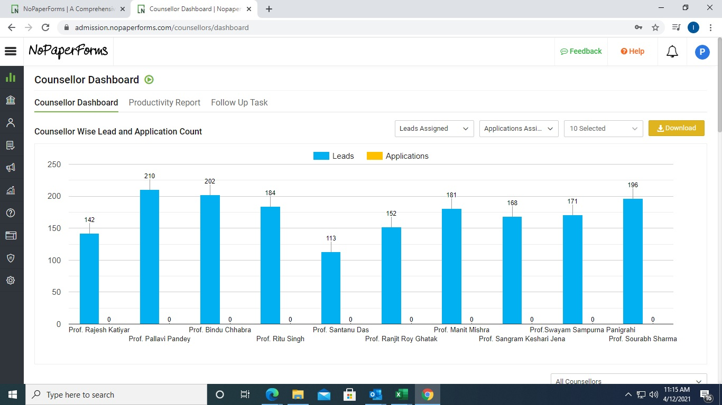

Areas of  e-governance | Year of implementation | Name of the Vendor with contact details | Link to relevant website/ document
Examination | 2011 | A & S Software Consultancy Private Ltd , G-14, 3rd Floor, South Extension-1, Main Market, New Delhi – 110049, director@assoftwaregroup.com | https://www.assoftwaregroup.com/aboutus/contact.aspx
Screen Shot:

